PROSPECT BROADVIEW

BOWLING CLUB
in association with
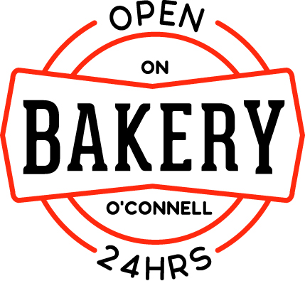

LADIES FOURS

Monday 24th October
9:30 for 10 am Start
Fours -Pairs -Pairs -Fours
(3 bowl pairs)
Two-Course Lunch
Wine and Nibbles
$100 per Team $1500 Prizemoney
CONTACT: Denise Caulfield 0419 803 694
caulfieldd@bigpond.com
Caddieshack will be in attendance.
PROSPECT BROADVIEW BOWLING CLUB, Collingrove Avenue, BROADVIEW

