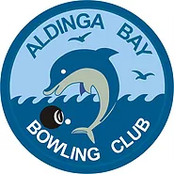

Aldinga Bay Bowling Club
extends an invitation to our
Women’s Fours Gala Day
Friday 29 November 2019
9:30am for a 10:00am start
$80 per team
Morning tea, lunch and afternoon tea included
Prizes and raffles
1 x game of 13 ends and 2 x games of 8 ends each
Club uniform please
Caddieshack Bowls will be in attendance

RSVP to Corrie by Friday 22 November 2019
E: corriefootedhp@gmail.com or M: 0468369071
Please advise of any dietary requirements

