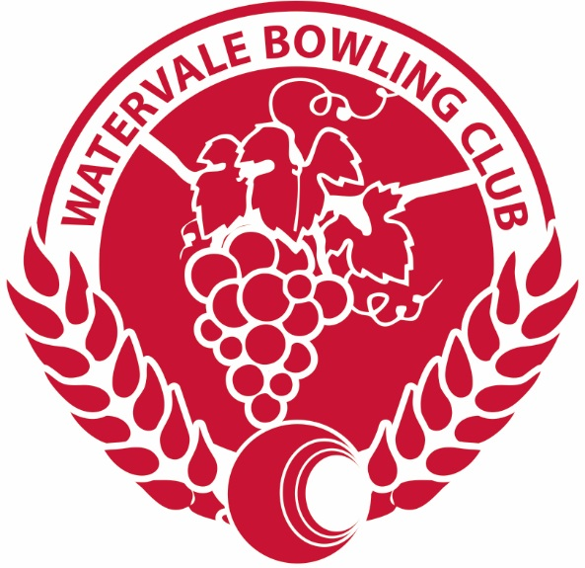

Watervale Bowling Club
Invites you to the

Kathy Ackland Memorial
Ladies Turkey Triples

Monday 14th February 2022
9.30 am for 10.00 start
Entry Fee $60 per team
Includes Lunch, Morning and Afternoon teas

Closing date 9th February

Dress Code: Club uniforms with a touch of Pink
To enter please contact

Marilyn Scott
Mobile: 0400975080
Email: marilynandpeter@bigpond.com

