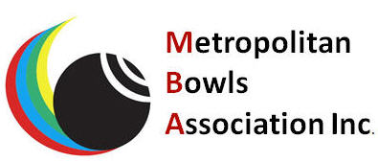
EXPRESSIONS OF INTEREST PRESTIGE MEDLEY
APRIL 9th & 10th 2022
TO BE PLAYED IN THE METRO AREA

CLUB. ___________________________

WOMEN’S SIDE
PLEASE PRINT
NAME | PLAY IN  DIV | PLAY AS  LEAD,SKIP etc |  | CONTACT  PHONE

MEN’S SIDE
PLEASE PRINT
NAME | PLAY IN  DIV | PLAY AS  LEAD,SKIP etc |  | CONTACT  PHONE

SELECTORS
PLEASE PRINT
NAME | PLAY IN  DIV | PLAY AS  LEAD,SKIP etc |  | CONTACT  PHONE

PLEASE RETURN TO MBA SECRETARY BY 11th FEBRUARY 2022
metrobowls@bigpond.com

