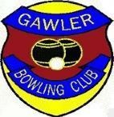GAWLER BOWLING CLUB INC

2021
MONTHLY

26thApril 24th May 28th June

26th JULY 23rd August

MONDAYS 9:30 for 10 am Roll up

3 GAMES X 10 ENDS (3 BOWLS) EXCELLENT PRIZE MONEY Casual Wear
ENTRIES : $10.00 PER PLAYER TEAM or SINGLE ENTRIES
Sausage Sizzle after the first game

Contact:-

Bob Gillies 0438 323 583, Kingsley Branson 8522 3457, or
Club e-mail address: gawlerbc@iinet.net.au

