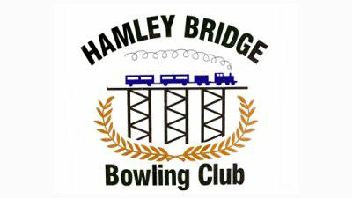

Hamley Bridge Bowling Club
Annual LES STOTT & JOE TILY Day
Open Fours Tournament
SUNDAY 28TH APRIL 2019
10am for 10.30 Start $60 a team.

Sponsored by:
Taylor & Forgie
Schahinger Motors

Entries to: Mal Obrien 0427 392 464
attaobrien@gmail.com
Harry Frencken 0429 792 173

