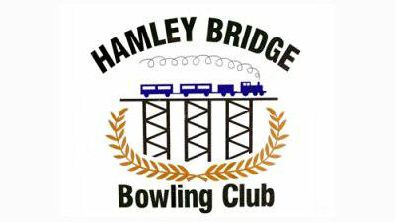

Hamley Bridge Bowling Club
Open Fours Tournament
Long Weekend Monday 1st October 2018
9.30 am for 10am Start $80 a team.
Medley Format—Fours/Pairs/Fours

Sponsored by:
Complete Laser Alignment Service
Multispares Truck Parts

Entries to: Mal Obrien 0427 392 464
attaobrien@gmail.com
Harry Frencken 0429 792 173

