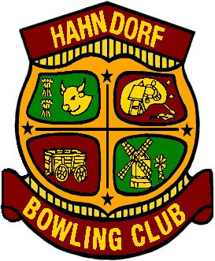
HAHNDORF BOWLING CLUB INC.

Mixed Fours Medley
Medley of Fours & Pairs

Monday 9th March 2020

9.30am for 10.00am start

$1,500 Prize Money

$80 per team, lunch included

Dress – bowls attire

Registrations to Phil Nagel 0407 974 424

