MT BARKER BOWLING CLLUB INC.
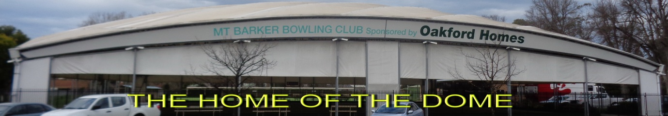
Mann Street P.O. Box 114 Mt Barker 5251 PH. 8391 1220 homeofthedome@gmail.com
LADIES MEDLEY GALA DAY
COLOURED SHIRT THEME
MONDAY NOVEMBER 19TH 2018
10AM START FOR 1030AM
4 GAMES
GAME 1: FOURS X 10 ENDS
GAME 2+3: PAIRS X 8 ENDS X3 BOWLS
GAME 4: FOURS X 8 ENDS
TIMES LIMITS APPLIES ALL GAMES
$80.00 PER TEAM
INCLUDING MORNING TEA / LUNCH / AFTERNOON TEA
ALL GAMES UNDER DOME – FIRST 14 TEAMS
CONTACT:
JOHN OR RAELENE CORNER: 83986824 (H) 0409695866 (M)
studley.rc@gmail.com
CLOSING DATE: THURSDAY 15TH NOVEMBER 2018
MT BARKER BOWLING CLLUB INC.
Mann Street P.O. Box 114 Mt Barker 5251 PH. 8391 1220 homeofthedome@gmail.com
ANNUAL STIRLING CUP
Mixed 4’s
SUNDAY 2ND DECEMBER 2018
10 AM START FOR 10.30 AM
3 GAMES - GOOD PRIZE MONEY
+ WINNERS NAME ON CUP
UNIFORM BOWLS ATTIRE

$80.00 PER TEAM

INCUDING MORNING TEA – LUNCH – AFTERNOON TEA
ALL GAMES UNDER DOME – MAX 14 TEAMS

CONTACT : JOHN CORNER 83986824 (H) OR 0409695866 (M)
EMAIL: studley.rc@gmail.com

CLOSING DATE : 17TH NOVEMBER 2018

