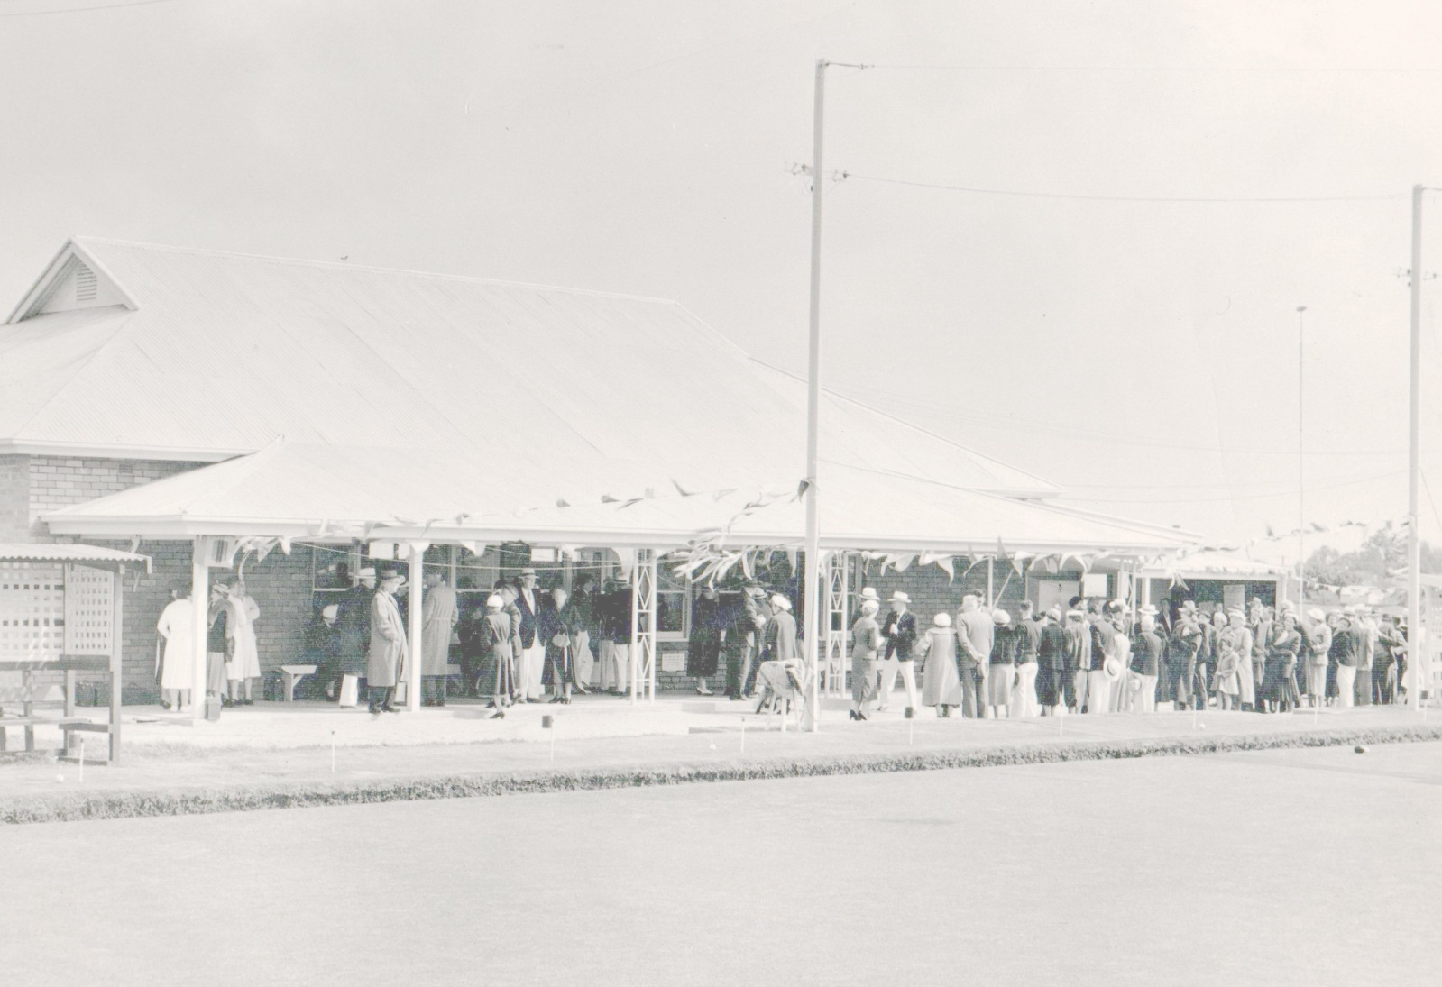

**CLARENCE GARDENS**

**BOWLING CLUB**

**(Home of the Knights)**

***Presents its…***

**OPEN GENDER 4’s TOURNAMENT**

***When…***

**Sunday 28th Nov 2021**

**9.00am for 9.30 start**

***Prizemoney…***

**Total - $3,200**

**1st - $1,200**

**2nd - $800**

**3rd - $600**

**Best winner each game - $200**

***Fees, format etc…***

**Entry - $100 per team and closes Fri 19th Nov**

**Format – 3 x games of 10 ends incl. 1 end roll-up for each game**

**Attire – Club or BA approved uniform.**

***Food…***

**Hot chicken lunch**

**(please let us know about dietary requirements)**

***Contact…***

**Entries to the Tournament Director Brett Baldey on 0437 497 543**

